TRAINING OF MICROSOFT MATHEMATICS TO IMPROVE THE QUALITY
Article Number :
82-302-1-SM Received :
23/01/2017
Accepted :
17/05/2017
Published :
Volume : 03
Issue : 01
June 2017
pp.392-395
OF LEARNING METHODS FOR TEACHERS IN JUNIOR SECONDARY SCHOOLS (SMP AND MTs) AT PONOROGO EAST JAVA INDONESIA

PELATIHAN MICROSOFT MATEMATIKA UNTUK MENINGKATKAN KUALITAS BELAJAR METODE UNTUK GURU Di SMP (SMP DAN MTs)
PONOROGO JAWA TIMUR INDONESIA

Kwardiniya Andawaningtyas^{1*}, Wuryansari Muharini K.¹, Ani Budi Astuti²
¹Department of Mathematics, Faculty of Mathematics and Natural Sciences
University of Brawijaya, Indonesia
²Department of Mathematics, Statistics Study Program, Faculty of Mathematics and Natural Sciences, University of Brawijaya, Indonesia
*email: akwardiniya@yahoo.com
ABSTRACT
All this time, mathematics has become the scourge for elementary and junior high school students, so that students are not well motivated to learn the material of Mathematics. Along with the development of computer technology, it can be used as one tool that can help the learning process. Mathematics software can be used to explain the difficult concepts in mathematics becomes easily, clearer, more interesting and fun. In Ponorogo, mathematics teachers have a meeting forum called the Subject Teacher Council (MGMP) of Mathematics. The general problems of the council is the less equality in opportunities of MGMP Mathematics teachers in Junior Secondary Schools (SMP and MTs) at Ponorogo to attain trainings for improving students skills in understanding the material of Mathematics and the limited insight of mathematics teachers about mathematics software that can be used as an instructional media of mathematics material. Therefore, the activity of microsoft mathematics training for mathematics teachers in Junior Secondary Schools at Ponorogo has been necessarily and urgently needed to improve the quality of learning methods. These software is open source software with less space requirement in the computer and easy installation.

KEYWORDS
Junior Secondary Schools, Teachers, Training, Microsoft Mathematics, Ponorogo.

INTRODUCTION
Primary and secondary education system in Indonesia is currently experiencing changes in the curriculum. Curriculum 2013 (K13) is applied by the government to replace the Unit Level Curriculum (SBC 2006). K13 Mathematics materials in the learning material is adapted to international standards so that the government hopes to balance the education in the country to study abroad (NN2, 2013). Regardless of the changing conditions of the existing curriculum in Indonesia, especially in the subjects of mathematics that requires logical thinking, a good mastery of competencies material will be very useful for students in understanding further the mathematics material [1].
The low mathematics learning outcomes caused by several factors, one of those is due to the demands of the curriculum more emphasis on the achievement of the target and is not the students understanding of mathematical concepts [2]. Another important factor is the delivery of the subject matter presented lectures in which the teacher is active while the students are passive. The result is process of memorization concepts or low understanding procedures of mathematics concepts and students could not apply it if more complex problems are given. According [3], learning by rote is not too demanding students activity of thinking and contains a bad effect on the mental development of students.
The use of computer facilities in some schools perceived lack of leverage in supporting teaching and learning process, especially in mathematics. The teachers did not know that currently there is some mathematical software that can be used as a tool to explain the concepts in Mathematics. If teachers can find only one of several mathematical software, then in addition to maximizing the computer facilities in schools, the students quality of learning mathematics can be improved.
Microsoft Mathematics is open source software with less space requirement in the computer. In addition to the easy installation, it is also very easy, even for those who had never known. Microsoft Mathematics provides a variety of tools that help students understand mathematics concepts with easily and quickly. Because it can be considered as a calculator, the device is very easy to operate without the need to learn too long. In addition, the results of calculation of the analytical results of the following explanation and graphical results can be stored so that it can be used as teaching materials by teachers. Because of these advantages, the executive team of this activity chose Microsoft Mathematics as an instructional media of learning materials in Mathematics. Microsoft Mathematics can be downloaded for free from http://bit.ly/MSMath. Figure 1 is shown Microsoft Mathematics display for solving a quadratic equation.
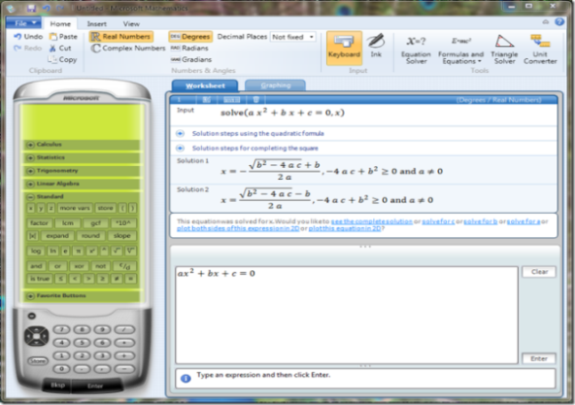

Figure 1. Microsoft Mathematics for Solving a Quadratic Equation
To obtain the target and the outcome of the activity, namely improving the quality of mathematics learning methods, the purpose of this study is to provide an opportunity and expand the horizons of MGMP mathematics teachers in MTs and SMP (Junior Secondary Schools) at Ponorogo to obtain training for improving students skills in understanding the mathematics material.

MATERIALS AND METHODS
The research model is the training of Mathematics Software. The training activities conducted by Lecturer of Mathematics Department, Faculty of Mathematics and Natural Sciences, University ofa Brawijaya.
The first phase was spreading the invitation to Junior Secondary Schools through Mathematics MGMP in Ponorogo to attract prospective participants. Because Microsoft Mathematics is open source software, then in the second stage performed an initial evaluation to determine how far the participants to know about Microsoft Mathematics. In the third stage of training was done by providing modules and manual procedures from Microsoft Mathematics. The training also provided various examples, by following the explanations of the instructor. Each participant was asked to bring a portable computer that can directly work on the worksheet using Microsoft Mathematics. In the fourth phase, participants were asked to fill out questionnaires regarding the implementation of the activities and expectations to these kinds of activities. The last stage, the evaluation of the training result for participants and activities are conducted.

RESULTS AND DISCUSSION
The training was attended by 35 mathematics teachers of SMP and 35 mathematics teachers of MTs in Ponorogo who enroll through Junior Secondary Schools Mathematics MGMP in Ponorogo (100% of the invited guests were present). The training location was in MTsN and SMPN I Ponorogo which have computer laboratorium with adequate internet installation.
Pretest as an initial internal evaluation was performed because the participants did not recognize the microsoft mathematics. Most of the participants could follow the explanation and installed the Microsoft Mathematics well. However, there was some participants who still just learning in using a laptop, so there was few difficulties in operation of Microsoft Mathematics. Figure 2 is a documentation of training activities.

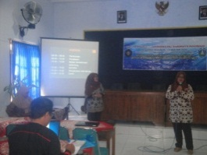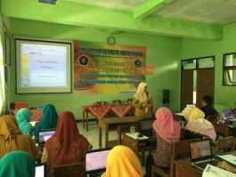

Figure 2. The Participants Followed the
Explanation of the Presenter

Furthermore, participants learned in groups following the Microsoft Mathematics guide modules and completing exercises using Microsoft Mathematics. Exercises were taken from the national exam question bank areas of mathematics and statistics. Some exercises can be directly solved by using the features of Microsoft Mathematics. But most of the exercises given were matters that require logical thinking in finding solutions. Exercises that have been done were stored in a worksheet that must be collected to the IbM team and as a replacement postest on the internal final evaluation. Figure 3 is a documentation of group learning activities.
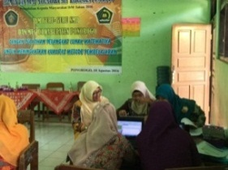
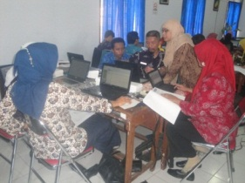

Figure 3. Group Learning Process Atmosphere of
Installing Microsoft Mathematics and Exercises

To measure the success level of this activity, evaluation to the participants and activities were conduted. The evaluation to the participants were: work on a worksheet according to the instructions on the module reaches 70% correct. From the training results, 94.3% of the MTs Mathematics teachers and 100% of SMP Mathematics teachers were doing the worksheet according to the instructions and correct. The evaluation of the training activities for Mathematics teachers of MTs and SMP in Ponorogo is considered highly successful as participants registered were all present and following the activities with the necessary requirements and expect a sustainable activity (100%). Therefore, the results of research evaluation is considered very good. Figure 4 is a documentation of partisipants presented activities.

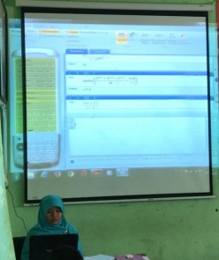
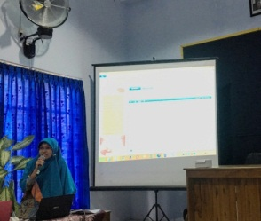

Figure 4. Participants Presented the Results in
the Form Exercises Worksheet

CONCLUSIONS AND SUGGESTION
The results obtained from the training implementation, that teachers get some materials that can be used as material enrichment and props in the classroom to improve teaching skills materials of Mathematics, that is Microsoft Mathematics Software, modules and worksheets. Therefore, mathematics teaching materials expected can be more easily understood by the students. In addition to the establishment of excellent sustainable cooperation between Mathematics MGMP of Junior Secondary schools in Ponorogo with the Department of Mathematics, Faculty of Mathematics and Natural Sciences, University of Brawijaya Malang, in the quality of learning methods Mathematics as IbM program outcomes can be achieved.

ACKNOWLEDGEMENTS
This paper is part of IbM Grants University of Brawijaya in 2016. We would like the first thank to Directorate General of Higher Education Indonesia and University of Brawijaya which have financed this event, and the second thank to Junior Secondary Schools (SMP and MTs) in Ponorogo as a partner of this event, and thank to anonymous reviewer to this paper.

REFERENCES

[1]Albrecht, K. 1992. Thought Power. (in Indonesian). Dahar Prize, Semarang.

[2]Marpaung, Y. 2001. Implementation of Realistic Mathematics Education in Indonesia. (Collection of Papers at the National Seminar Day: Application of Realistic Mathematics Education In Schools And Madrasah). (in Indonesian). Medan.

[3]Mukhayat, T. 2004. Develop to Good Learning Method for Children. (in Indonesian). FMIPA UGM, Yogyakarta.

[4]NN1. 2012. Education in Ponorogo. (in Indonesian). (http://id.wikipedia.org/wiki/Kabupaten_Ponorogo#Pendidikan). Access Date February 23, 2015.

[5]NN2. 2013. Curriculum 2013. (in Indonesian). (http://id.wikipedia.org/wiki/Kurikulum_2013). Access Date February 23, 2015.

[6]NN3. 2013. Tutorial Microsoft Mathematics, Mathematics MGMP in SMK Boyolali. (in Indonesian) (http://mgmp-mat-smk-byl.blogspot.co.id/2013/02/tutorial-microsoft-mathematics.html). Access Date October 15, 2016.

[7]Rohanah, E. 2015. Effect Analysis of Headmaster Style to Performance Certified Teachers. (in Indonesian). (http://dikpora.ntbprov.go.id/index.php/tutorials/artikel-pendidikan-ntb). Access Date May 1, 2015.

[8] Romanita, H. A. 2008. Learning Patterns Students In Mathematics Story Problem Solving in Elementary School IV (Case Study at SDN 1 Karang Talun Sragen, Academic Year 2007/2008). (in Indonesian). Thesis S1. FKIP UMS, Surakarta.

